The Sorrowful Heart of Mother Mary

June 21st, 2021

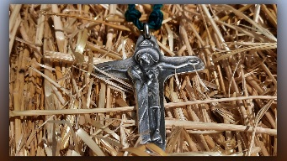
We began the Rosary of the Sorrowful Mysteries and halfway through the first decade, Blessed Mother Mary appeared in our midst with anguish on her face.

You could very much sense her sadness and grief. She was in the garden with Jesus and she took from the angel’s hand, who was comforting her Son, a stack of pure white, fine linen hand towels neatly folded. Mother began to wipe the bloody sweat gently and tenderly from her Son’s brow and then folded a few of the blood-soaked towels and put them lovingly back on top of the stack of linen towels.

When the second decade started, Blessed Mother was down on her hands and knees soaking up His blood on the ground from the Scourging at the Pillar with more of the white linen towels until each one of them turned blood red.

On the third decade, as Mother Mary was tending to Jesus’ head wounds from the Crowning of Thorns and wiping His blood meticulously with the utmost care, she said to us, “Children, console Him.”

Then I saw Mother walking behind Jesus on the sorrowful Way of the Cross, again she used the linen towels, and was wiping up His precious blood that she found on the ground, and folded the linen very carefully, putting them back neatly on the stack. At this point, her sorrow was beyond measure, but you could sense she was still praying for her Son’s enemies.

Finally Blessed Mother was kneeling at the foot of the cross again soaking up her Son’s blood that was streaming down from the cross and clutching her heart. You could feel her acute pain and tears fell from my eyes as I bowed my head low, and when I looked up again, Mother Mary was now holding an entire stack of red, blood soaked linen towels.

Dear Family, all of us at the Sacred Heart Refuge wear the sorrowful crucifix which depicts Christ on the Cross with Mary comforting Him. Blessed Mother is asking all of us Heartdwellers to comfort her Son, spend time with Him in loving consolation. When we do this, she assures us that we will all better understand and draw closer to His Sacred Heart and her immaculate heart.

God bless you dear ones.

